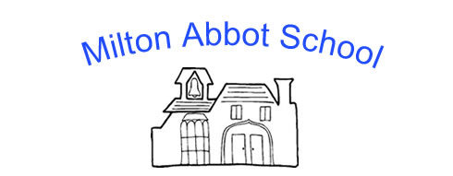

NOMINATION FORM – November 2021
Election for a parent governor at Milton Abbot School
Full name: ____________________________________________________________________
Children in year(s): _____________________________________________________________
Pen Portrait (maximum 100 words) *

I wish to serve as a Parent Governor and to be a candidate if an election is necessary. I have read the rules regarding the eligibility to become a governor which I received with the nomination form and I confirm that I am eligible to serve as a School Governor.
Signed:
Date:
Please return this form to clerk to governors at: clerk.miltonabbot@gmail.com
* If you wish you can include a few details about yourself and why you would like to become a governor (not exceeding 100 words). This will then be circulated to all parents to help them decided who to vote for if an election is required.

*

References

Please can you provide contact details for 2 referees.

Name: | Name:
Email: | Email:
Telephone: | Telephone:

