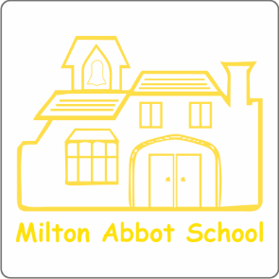

27th September 2022
Dear Parents and Carers
I am delighted to be able to share with you the OFSTED report from our recent graded inspection on September 13th and 14th. As I have already said, receiving notification of an inspection so early in the term was a real challenge! We were very much in the throws of settling back into school with new routines (and for me, learning the children’s names!) so the team had to really pull together to be as ready as possible for all the inspection activities. All of the Milton Abbot staff were tremendous in their efforts and we were fantastically supported by DMAT colleagues throughout the whole inspection.
OFSTED inspections are required by law and intend to provide information to parents, to promote improvement and to hold schools to account for the public money they receive. During the two days Inspectors talk to the headteacher, governors, staff and pupils, and consider the views of parents. Inspectors spend most of their time observing a wide range of lessons and looking at the quality of education in the school and the impact of the curriculum. Inspectors give specific attention to the acquisition of knowledge, understanding and skills in lessons. They also look at the personal development, behaviour, attitudes and welfare of pupils at the school, the promotion of spiritual, moral, social and cultural development; and how well the school is led and managed.
Inspectors make graded judgements on key areas:
- the quality of education
- behaviour and attitudes
- personal development
- leadership and management
- overall effectiveness
Inspectors use the following 4-point scale to make all judgements:
- grade 1 (outstanding)
- grade 2 (good)
- grade 3 (requires improvement)
- grade 4 (inadequate)
As you will see from the report, we received good judgements across all areas. This is testament to the hard work and dedication from subject leaders, teachers and support staff across the school. We are particularly proud of the strengths in Maths and Reading and are looking forward to continuing to develop the wider curriculum. We were in agreement that this is a next step as we are only term two into a new DMAT curriculum and have plans for supporting and developing teachers.
I was extremely proud of the children and how inspectors picked up on the excellent relationships between everyone in school. The report quotes that children ‘passionately believe that everyone should be treated equally’.
This inspection marks a key turning point for Milton Abbot as the school is now lifted out of the previous ‘requires improvement’ judgement. We are excited about taking the school forward and going from strength to strength, continuing the journey of improvement. Thank you to the whole school community for your continued support.
Best Wishes
Lisa Paton

