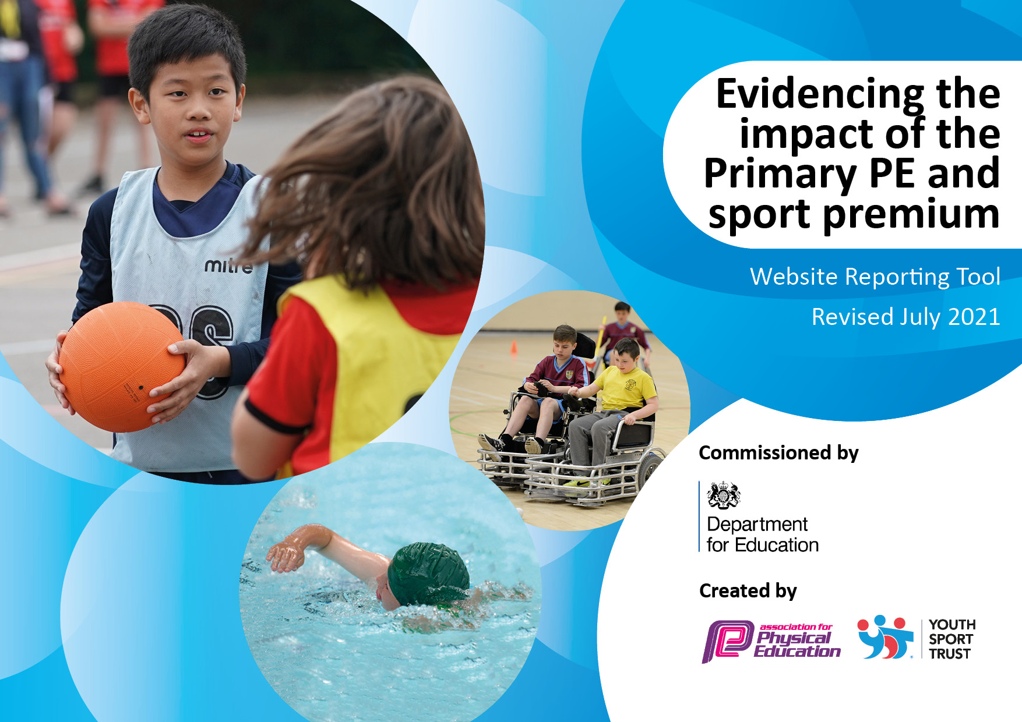
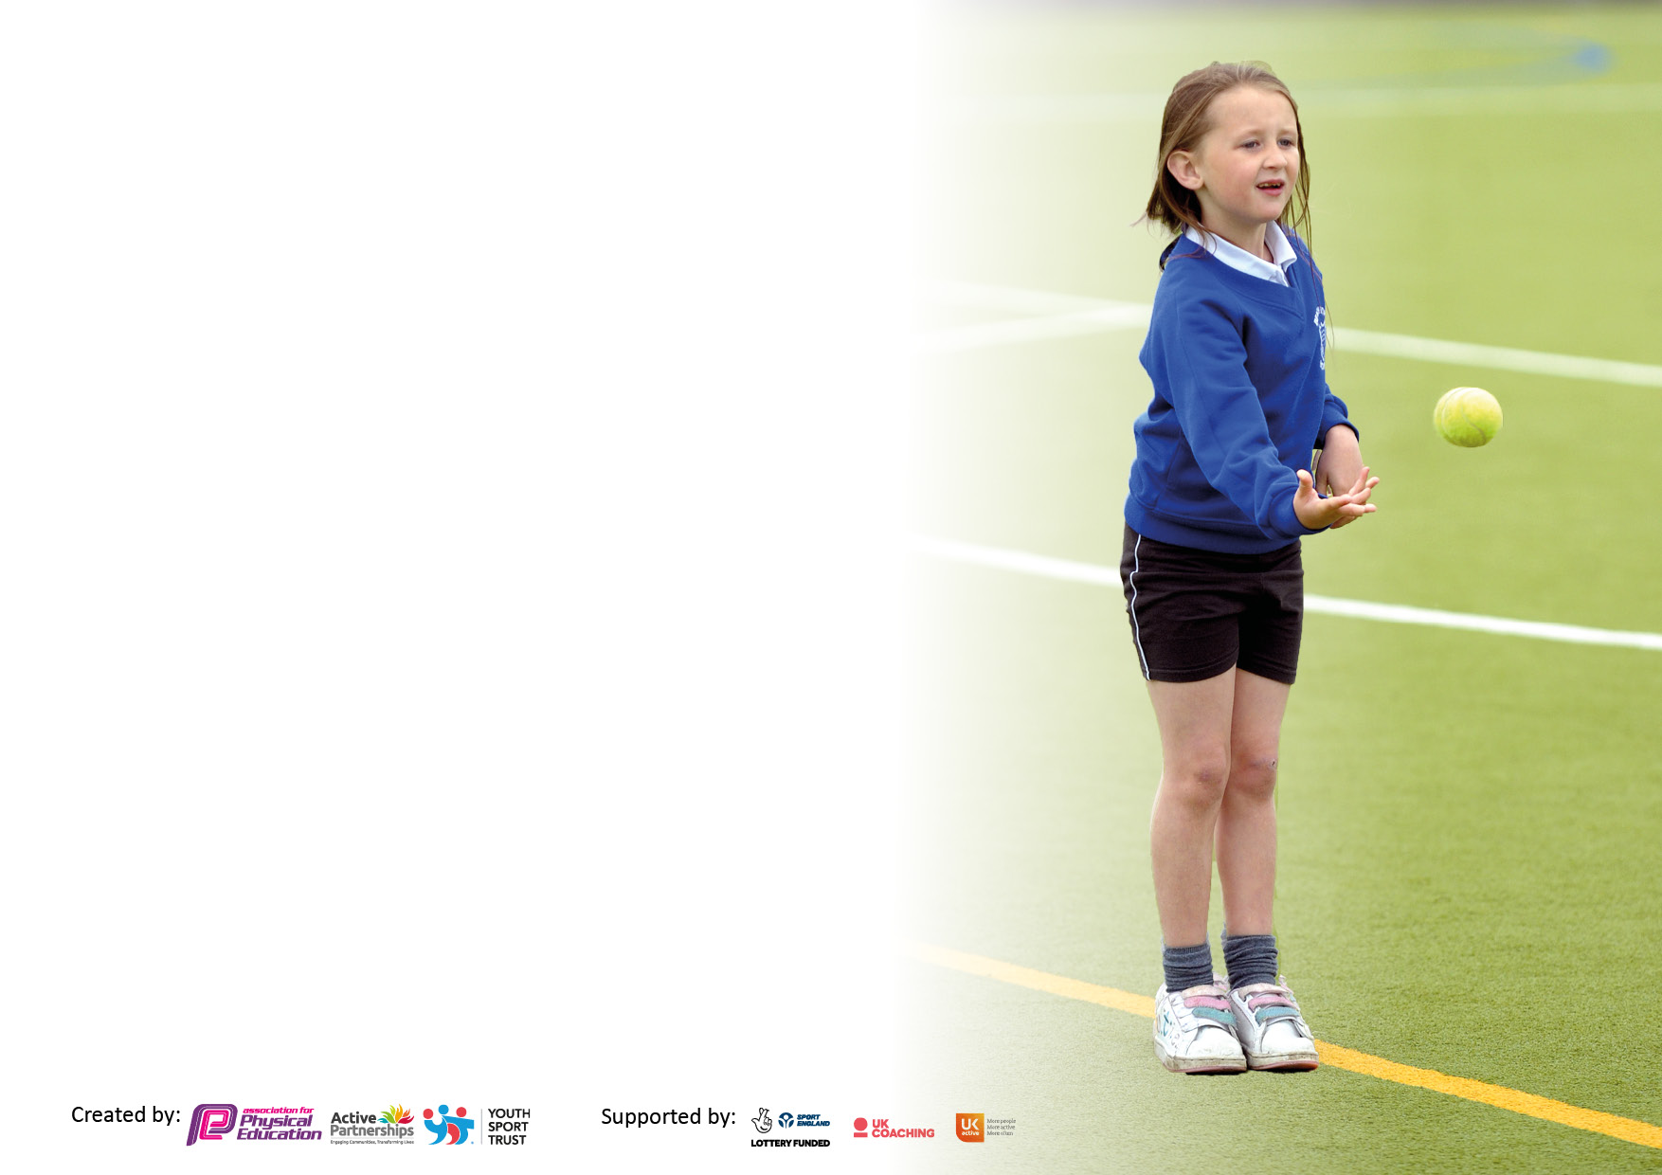

It is important that your grant is used effectively and based on school need. The Education Inspection Framework makes clear there will be a focus on ‘whether leaders and those responsible for governors all understand their respective roles and perform these in a way that enhances the effectiveness of the school’.

Under the Quality of Education Ofsted inspectors consider:
Intent - Curriculum design, coverage and appropriateness
Implementation - Curriculum delivery, Teaching (pedagogy) and Assessment
Impact - Attainment and progress

To assist schools with common transferable language this template has been developed to utilise the same three headings which should make your plans easily transferable between working documents.

Schools must use the funding to make additional and sustainable improvements to the quality of Physical Education, School Sport and Physical Activity (PESSPA) they offer. This means that you should use the Primary PE and sport premium to:

- Develop or add to the PESSPA activities that your school already offer
- Build capacity and capability within the school to ensure that improvements made now will benefit pupils joining the school in future years
- The Primary PE and sport premium should not be used to fund capital spend projects; the school’s budget should fund these.

Pleasevisitgov.ukfortherevisedDfEguidanceincludingthe5keyindicatorsacrosswhichschoolsshoulddemonstrate animprovement.Thisdocumentwillhelpyoutoreviewyourprovisionandtoreportyourspend.DfEencouragesschools to use this template as an effective way of meeting the reporting requirements of the Primary PE and sport premium.

We recommend you start by reflecting on the impact of current provision and reviewing the previous spend.

Schools are required to publish details of how they spend this funding, including any under-spend from 2019/2020, as well as on the impact it has on pupils’ PE and sport participation and attainment. All funding must be spent by 31st July 2022.

We recommend regularly updating the table and publishing it on your website throughout the year. This evidences your ongoing self-evaluation of how you are using the funding to secure maximum, sustainable impact. Final copy must be posted on your website by the end of the academic year and no later than the 31st July 2021. To see an example of how to complete the table please click HERE.

Details with regard to funding
Please complete the table below.

Total amount carried over from 2022/23 | £0
0Total amount allocated for 2023/24 | £16,670
How much (if any) do you intend to carry over from this total fund into 2024/25? | £0
Total amount allocated for 2023/24 | £16,670
Total amount of funding for 2023/24. To be spent and reported on by 31st July 2024. | £16,670
Swimming Data
Please report on your Swimming Data below.

Meeting national curriculum requirements for swimming and water safety.

Based on 2022/23 data
What percentage of your current Year 6 cohort swim competently, confidently and proficiently over a distance of at least 25 metres? | 75%
What percentage of your current Year 6 cohort use a range of strokes effectively [for example, front crawl, backstroke and breaststroke]? | 75%
What percentage of your current Year 6 cohort perform safe self-rescue in different water-based situations? | 75%
Schools can choose to use the Primary PE and sport premium to provide additional provision for swimming but this must be for activity over and above the national curriculum requirements. Have you used it in this way? | Yes

Action Plan and Budget Tracking
Capture your intended annual spend against the 5 key indicators. Clarify the success criteria and evidence of impact that you intend to measure to evaluate for pupils today and for the future.

Academic Year: 2023/24 | Total fund allocated: £16,200 | Date Updated: 20/06/2023
Key indicator 1: The engagement of all pupils in regular physical activity – Chief Medical Officers guidelines recommend that primary school pupils undertake at least 30 minutes of physical activity a day in school |  |  |  | Percentage of total allocation:
 |  |  |  | £4479 –25%
Intent | Implementation |  | Impact
Your school focus should be clear what you want the pupils to know and be able to do and about  what they need to learn and to  consolidate through practice: | Make sure your actions to achieve are linked to your intentions: | Funding allocated: | Evidence of impact: what do pupils now know and what can they now do? What has changed?: | Sustainability and suggested next steps:
Training for children as Sports Leaders  To provide a greater number and frequency of clubs and opportunities, so that all children can engage in a more active and healthy lifestyle  To promote a more active and healthy lifestyle  To engage with parents/carers to support children to a more active and healthy lifestyle  To ensure that all children starting secondary school can confidently and safely ride a bike  Provide enhanced playtime equipment, games and structured play to engage children in physical activity | Training provided  Offer sports clubs as extra curricular items.  Engage in healthy lunches, drinks.  Support Daily physical activity  Promote healthy lifestyles and information to parents  Bikeability  New PE equipment  Training for MTAs | £100  £1482 (£38 weekly)  £50  £50  £50  £2617 |  | Legacy training for future year groups  Engagement in additional activities that will become lifelong habits  Creating daily healthy habits  Parental impact to provide future support for their children  Children learning a life skill  Daily physical activity including games and structured play become habit forming.

Key indicator 2: The profile of PESSPA being raised across the school as a tool for whole school improvement |  |  |  | Percentage of total allocation:
 |  |  |  | £1450 – 8%
Intent | Implementation |  | Impact
Your school focus should be clear what you want the pupils to know and be able to do and about  what they need to learn and to  consolidate through practice: | Make sure your actions to achieve are linked to your intentions: | Funding allocated: | Evidence of impact: what do pupils now know and what can they now do? What has changed?: | Sustainability and suggested next steps:
Designated Leadership time – planning, assessment, logistics, monitoring of impact.  To ensure that all children have the opportunity to develop to their potential – this includes SEND and Gifted and Talented children  Promote and celebrate sports outside of school to increase daily activity. | Release time for PE lead to be in schools to support PE provision  A wide range of opportunities for children to develop to their sporting potential  Involvement in inclusion games, visits from SEND athletes, support as required to ensure that SEND does not become a barrier  Opportunities for gifted and talented children to progress in PE and sports.  Engage in and promote positive sporting experiences outside of the classroom/school.  Attending sporting events for participation/watching for inspiration | £450  £500  £500 |  | PE lead succession planning  Opportunities to participate in sport to form habits of daily physical exercise.  Inspiration to participate in sport outside of school.

Key indicator 3: Increased confidence, knowledge and skills of all staff in teaching PE and sport |  |  |  | Percentage of total allocation:
 |  |  |  | £6,531 - 40%
Intent | Implementation |  | Impact
Your school focus should be clear | Make sure your actions to | Funding | Evidence of impact: what do | Sustainability and suggested
what you want the pupils to know | achieve are linked to your | allocated: | pupils now know and what | next steps:
and be able to do and about | intentions: |  | can they now do? What has
what they need to learn and to |  |  | changed?:
consolidate through practice:
Employed PE Specialist Teacher to deliver CPD to classroom teachers.  ‘Real PE’ PE curriculum programme to ensure quality PE provision | PE specialist to visit school on a weekly basis to work with each class to offer CPD and quality first sports provision.  Programme of learning to ensure quality first teaching and provision of sport. | £4,865  £1,666 |  | Long term CPD provision for all teachers  Quality of curriculum for all teachers within PE.

Key indicator 4: Broader experience of a range of sports and activities offered to all pupils |  |  |  | Percentage of total allocation:
 |  |  |  | £2500 –15%
Intent | Implementation |  | Impact
Your school focus should be clear | Make sure your actions to | Funding | Evidence of impact: what do | Sustainability and suggested
what you want the pupils to know | achieve are linked to your | allocated: | pupils now know and what | next steps:
and be able to do and about | intentions: |  | can they now do? What has
what they need to learn and to |  |  | changed?:
consolidate through practice:
Additional To provide transportation solutions to ensure that rurality is not an issue  Competitive and non-competitive sports days to increase enjoyment for all children | Provide transport to access events outside of school.  Avoid rurality as a barrier.  Planning, implementation and teacher release time for competitive sport events. | £2000  £500 |  | Long term participation in sports and healthy daily activity  Engagement in healthy habits

Key indicator 5: Increased participation in competitive sport |  |  |  | Percentage of total allocation:
 |  |  |  | £1710 – 10%
Intent | Implementation |  | Impact
Your school focus should be clear | Make sure your actions to | Funding | Evidence of impact: what do | Sustainability and suggested
what you want the pupils to know | achieve are linked to your | allocated: | pupils now know and what | next steps:
and be able to do and about | intentions: |  | can they now do? What has
what they need to learn and to |  |  | changed?:
consolidate through practice:
To ensure that all children starting secondary school are confident and competent swimmers  To take part in a range of competitive and non-competitive sporting events | Provide swimming lessons for all children in all classes.  Engaging children in competitive sport through the creating of Trust/Hub-Wide events.  Release time for staff to facilitate, plan and manage | £1260  £450 |  | Long term daily physical habits of swimming  Long term daily physical activity in competitive sport.

Signed off by
Head Teacher:
Date:
Subject Leader:
Date:
Governor:
Date:

